**CREATING STUDENTS TABLE**

create table students (

id int not null auto_increment,

batch_data int ,

name varchar(200),

email varchar(100) unique,

primary key(id)

);

insert into students (batch_data,name,email) values (2,'ganesh','ganesh@gmail.com'),(2,'kalyan','kalyan@gmail.com'),(3,'venu','venu@gmail.com'),

(3,'rahul','rahul@gmail.com'),(1,'jeeva','jeeva@gmail.com'),(2,'yeswanth','yeswanth@gmail.com'),(1,'poorna','poorna@gmail.com'),(1,'dheva','dheva@gmail.com'),

(3,'avinash','avinash@gmail.com'), (2,'sanjay','sanjay@gmail.com'),(3,'sanjaykhan','sanjaykhan@gmail.com'),(1,'siva','siva@gmail.com');

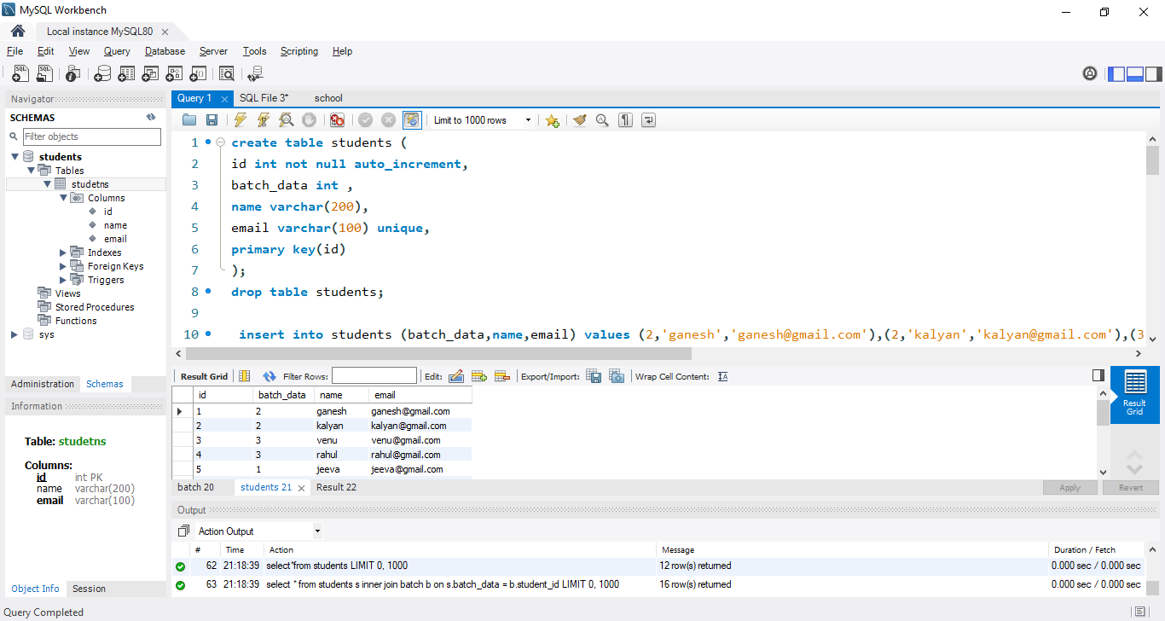

**CREATING BATCH TABLE**

create table batch (

batch_id int not null auto_increment,

student_id int,

batch_name varchar(100),

primary key (batch_id),

foreign key(student_id) references students(id)

);

drop table batch;

insert into batch (student_id,batch_name) values (1,'B30WD'),(2,'B32WD'),(3,'B33WD');

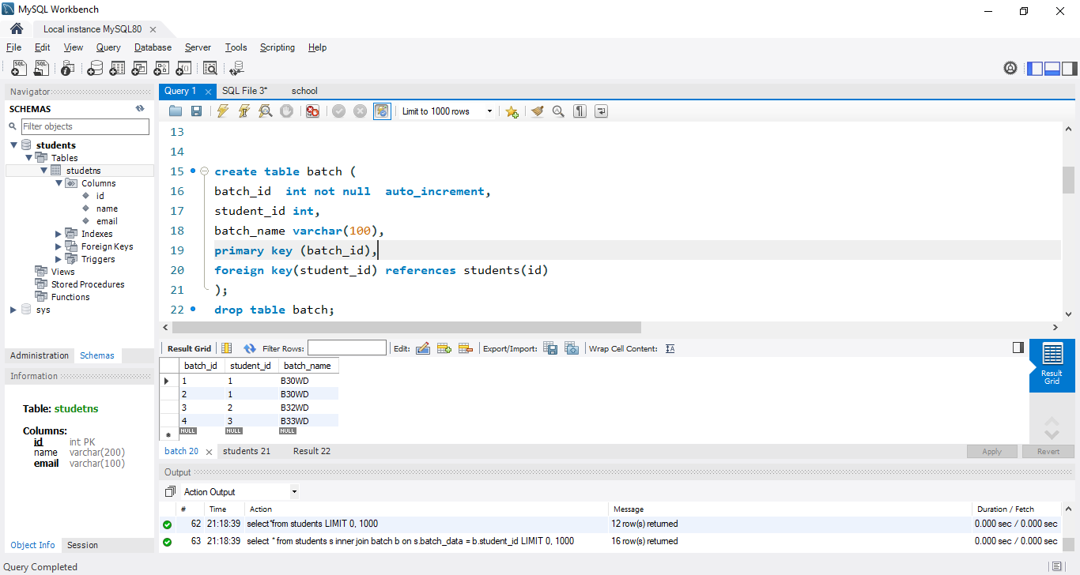

**JOINNING STUDENTS && BATCH TABLE**

select * from students s inner join batch b on s.batch_data = b.student_id;

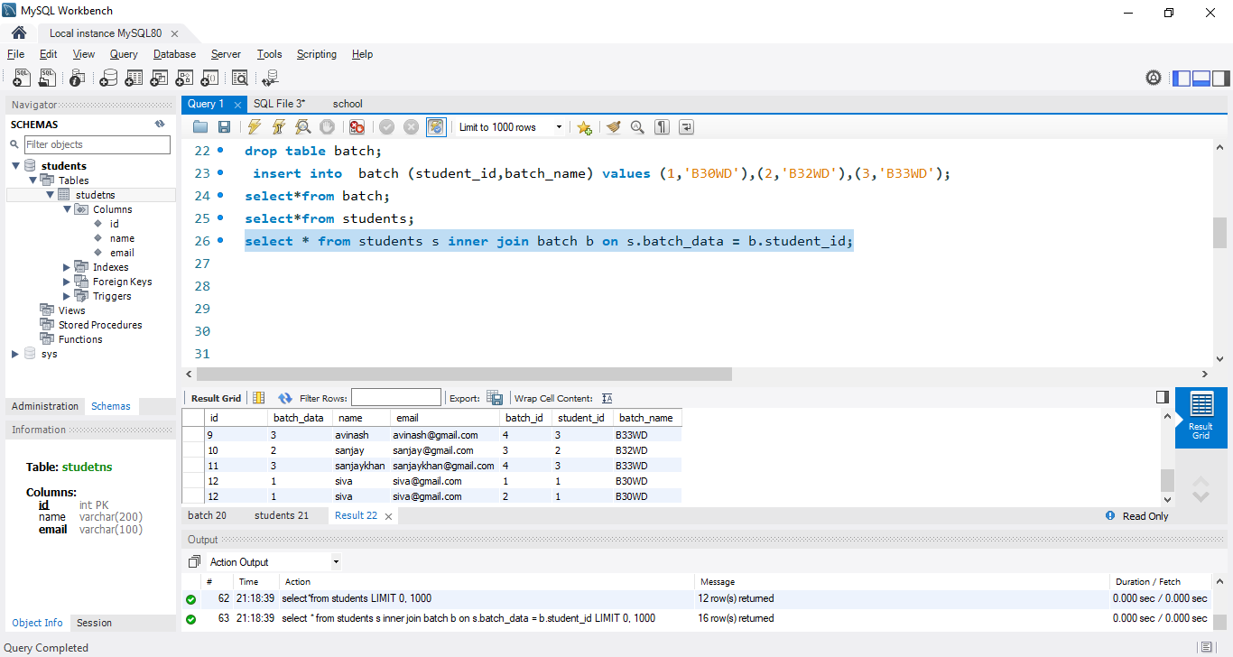

**CREATING TASKS TABLE**

create table tasks(

task_id int not null auto_increment,

task_assigned_id int not null ,

no_of_tasks_completed int ,

primary key (task_id),

foreign key (task_assigned_id) references students(id)

);

select*from tasks;

insert into tasks (task_assigned_id,no_of_tasks_completed) values (1,10),(2,13),(3,5),(5,11),(6,18),(4,null),(7,4), (8,20),(9,null),(10,null);

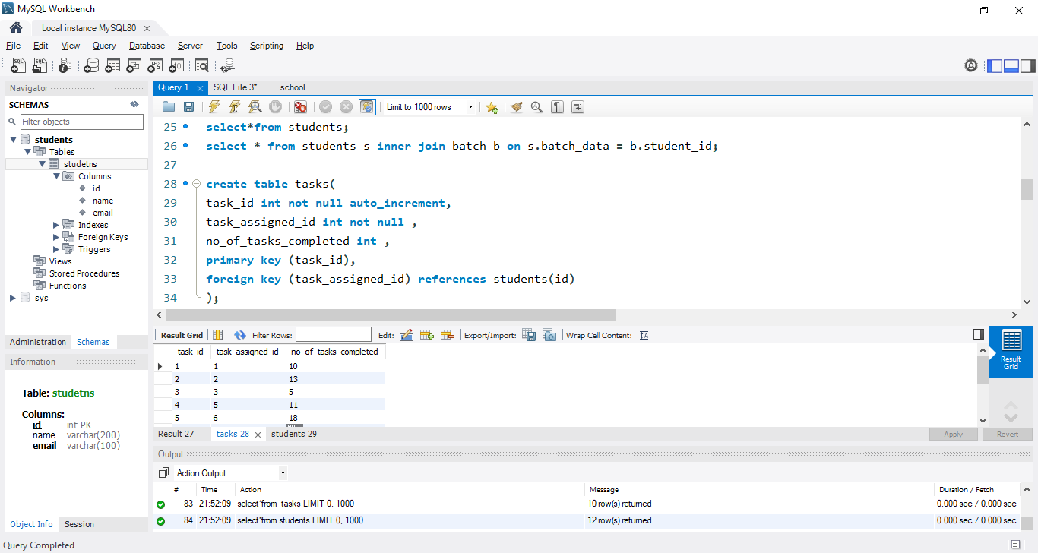

**JOINNING TASKS && STUDENTS TABLE**

select * from students s left join tasks t on s.id=task_id;

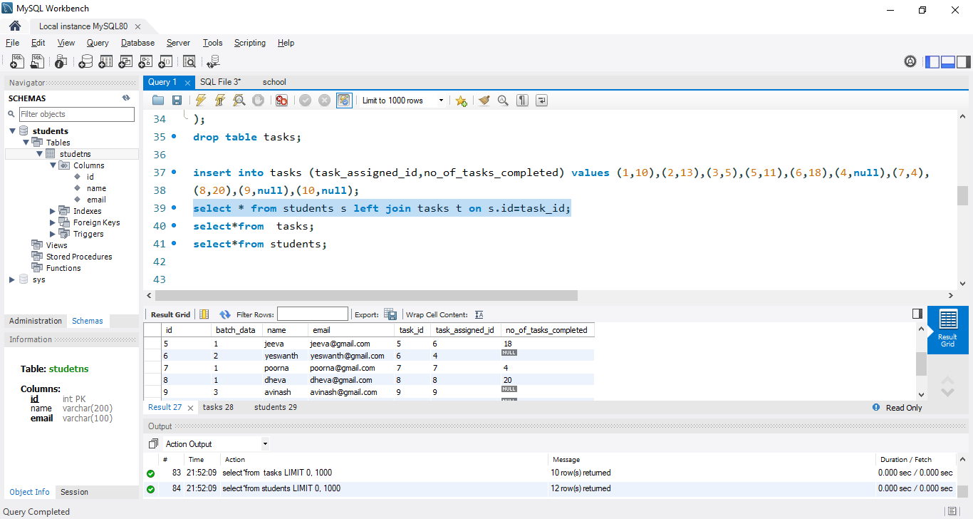

**CREATING MENTOR TABLE**

create table mentors(

mentor_id int not null auto_increment,

mentor_name varchar(100) not null,

primary key(mentor_id)

)

insert into mentors (mentor_name) values ('LAVISH'),('SIVARANJINI'),('MOHAN_ROA');

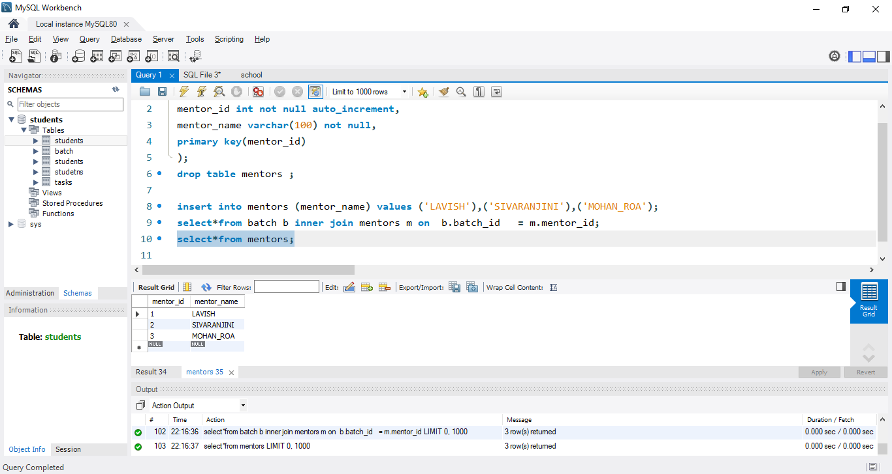

**JOINNING BATCH && MENTOR TABLE**

select*from batch b inner join mentors m on b.batch_id = m.mentor_id;

